This is the location of our repository: **https://github.com/russell1542/CMSC_495_Group_6**. I created this repository specifically for this project. If anyone wants the password, let me know. I have no interest in this repository, I will be cloning it from here into my personal repository at the end of the semester. I would recommend everyone else do the same.

So, in order to keep it easy, we’ll only focus on a few key git terms.

**Repository** is where the project is stored. Github is the remote repository we’ll be using.

**Cloning** is making a local copy of the remote repository. This will be on your machine.

**Branching** is deviating from the master to continue developing. You create a branch so that any work you do does not affect the master. This is the best thing for version control

**Commit** saves the changes you’ve made to the repository. You’re **commit**ing the changes to be approved.

**Push** is when the lead developer pushes all of the commits to the remote repository.

**Pull** is when each individual pulls from the remote repository. This verifies that you receive all of the commits from throughout the team.

**FIRST STEPS:**

I will show the process for the IDE Netbeans. I am most familiar with it. I’m also good in Visual Studio if anyone wants to use that. Any other IDE, let me know and I’ll see if I can help you.

The first thing you want to do is clone the repository. By cloning the remote repository, you are granted access to said repository; you can then pull and commit.

### Cloning the Code Repository in NetBeans

In NetBeans, navigate to Team > Clone (or Team > Git > Clone). Copy and paste the Repository URL (**https://github.com/russell1542/CMSC_495_Group_6**) into the text field that appears. Enter your login information and click Next.

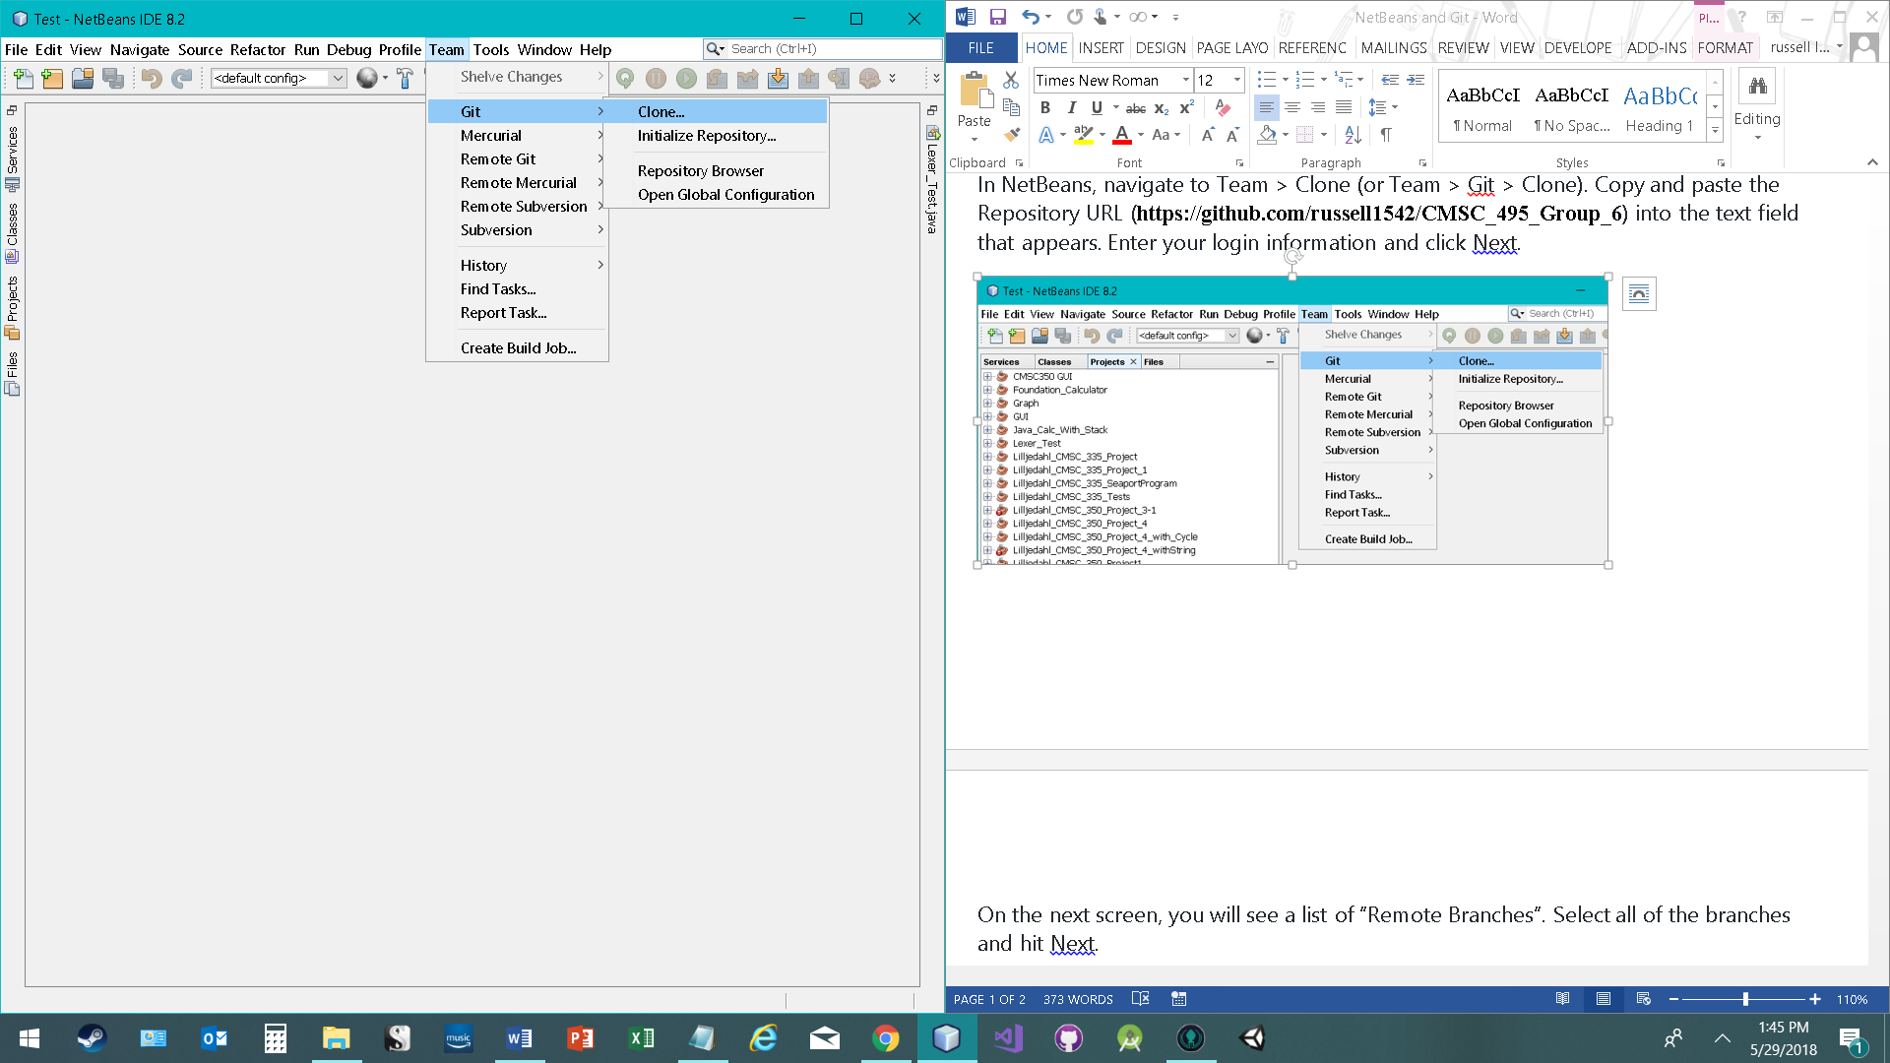

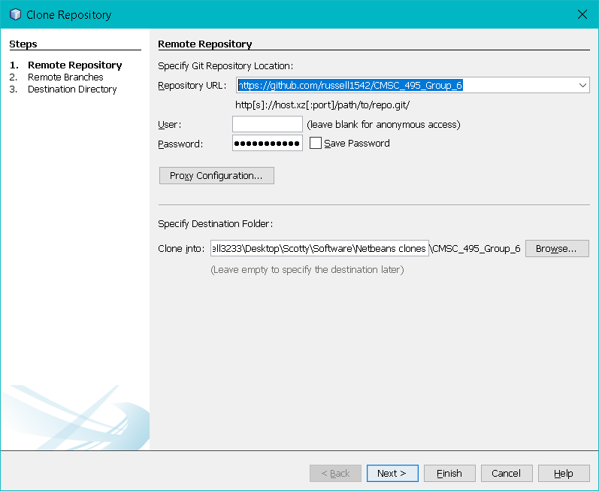

On the next screen, you will see a list of “Remote Branches”. Select all of the branches and hit Next.

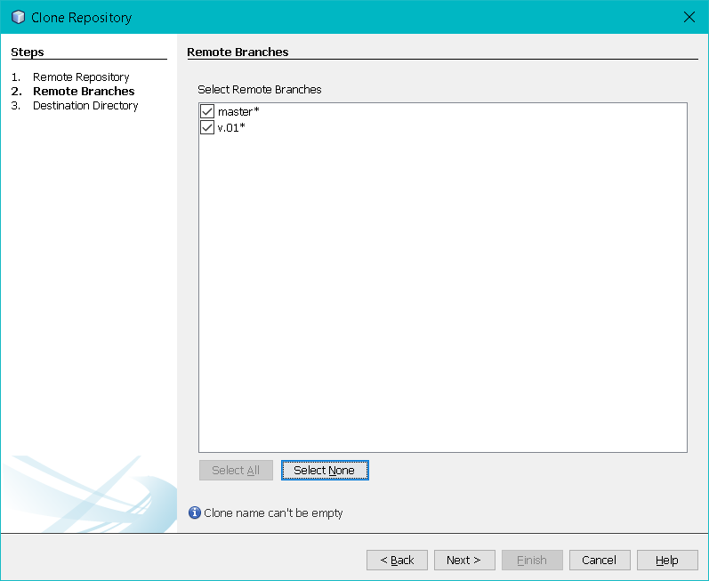

Enter the local directory in which you want to store local copies of the repository. Keep the clone name the same.

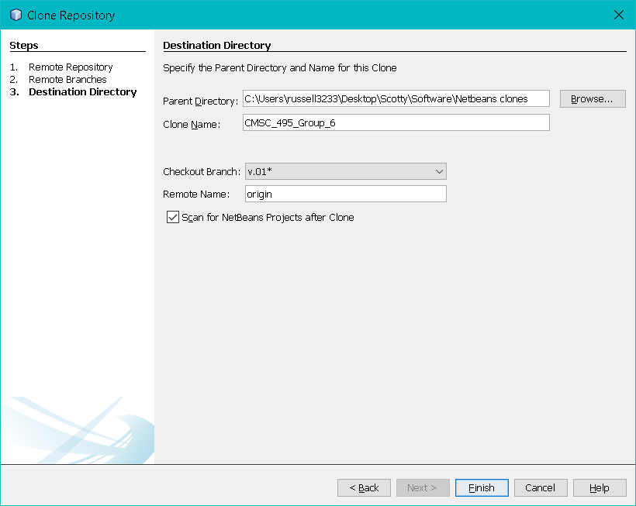

In the Parent Directory, what you see is my local path. The clone name remains the same. I made a v.01 branch. **NEVER WORK FROM THE MASTER BRANCH!!!!!** Oncewe start getting a bit further, we’ll begin adding additional branches. At the end of the sprints, we can test the branches. If they work, we merge them with the master and lock that current branch.

Click “Finish”, and NetBeans should prompt you to open any projects found in the repository.

### Committing Changes

This is an easy one. Right click on the project, then go to Git > Commit.

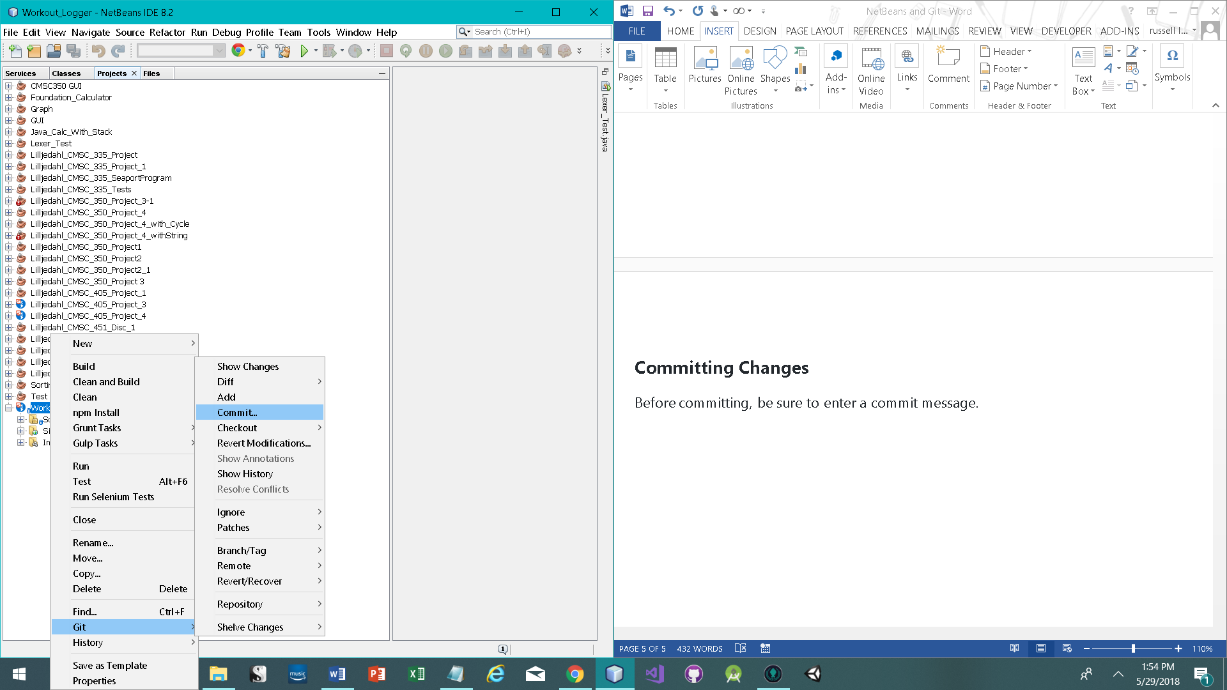

Before committing, be sure to enter a commit message.

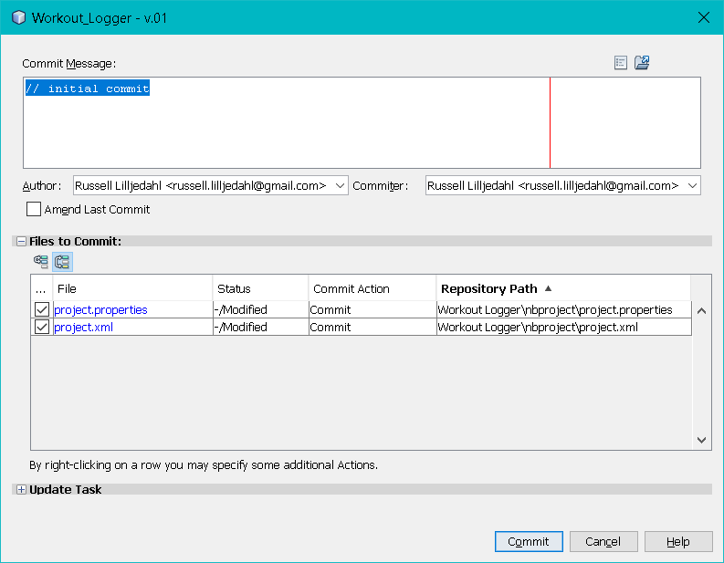

Then just click commit.

**Pulling the repository**

Before you begin working for the day, make sure you do a pull. Again, right click on the project, then Git > Remote > Pull.

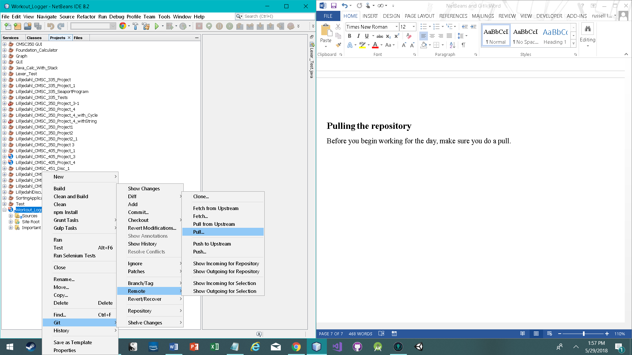

Verify the repository.

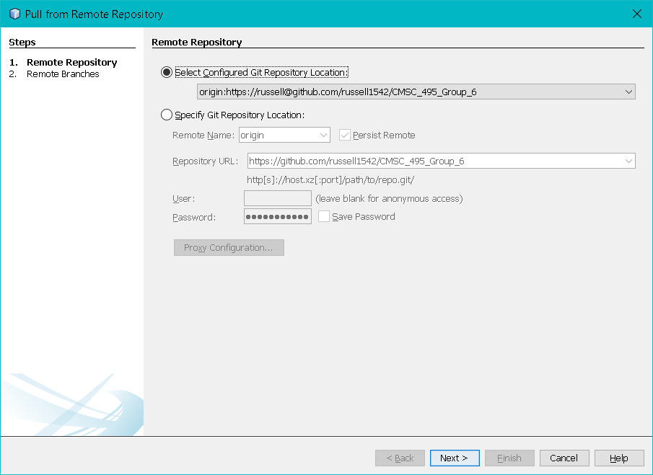

Select all branches, then finish.

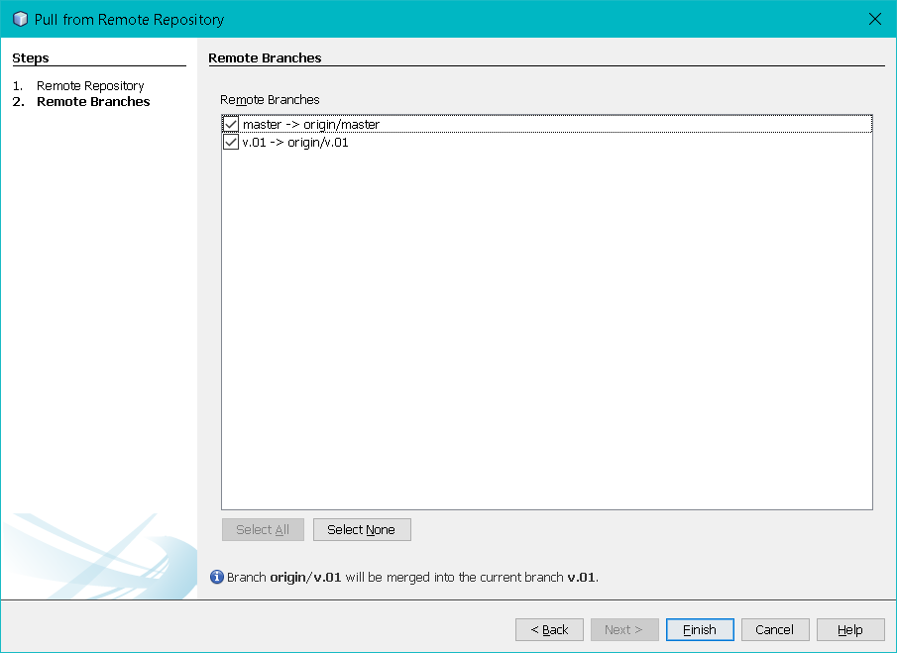

Now your project should be up to date.